**Module Unit – 4COM2006, Team Software Project**

**Interim Report**

**Project Title – Educational Game**

**Student ID – 21008521**

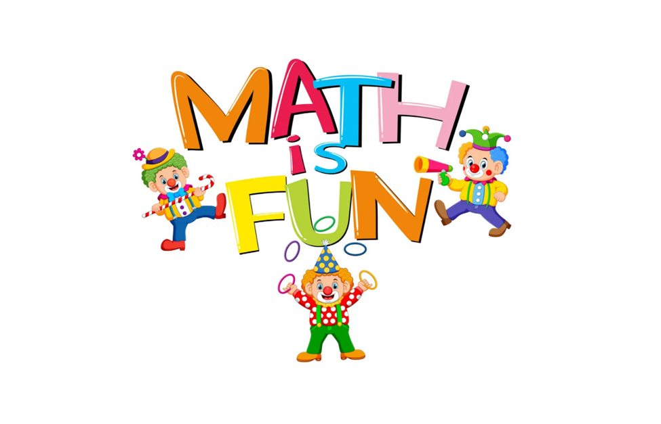

**Authored By: Dhyan Nilesh Patel**

**Date: 1/03/2022**

1. **Reconfirmation of Project Aims**

This report summarises the progress of my Team Software Project. After an initial discussion, the decision was made to develop the Educational Game project. The aims of this project are briefly summarised as:

* Children in everyday life are increasingly using educational games. The aim of my educational game is to help comprehend concepts, learn domain knowledge, and prosper in the process of finding solutions to difficult or complex issues by playing a game.
* Develop a working prototype towards the realization of the application to help the children aged between 3 to 15 to learn elements of mathematics.
* Provide the children with some beneficial knowledge of mathematics and show them how fun maths can be. This application will help them in their studies and make them more interested in mathematics. The aim of this application is to give children the opportunities to explore fundamental concepts, such as counting, geometry, and the use of arithmetic operations.
* Australian research published in 2011 found that playing maths games gives a significant boost to children’s learning, with 83% of students and 100% of teachers reporting a marked improvement. Games were also reported to increase children’s enjoyment of maths and boost their confidence.
* My role in the group is to do some background research, concept design, and project planning. I have also made a working prototype of our project idea using Figma and for the programming part, I have used Scratch.

**Figure 0**

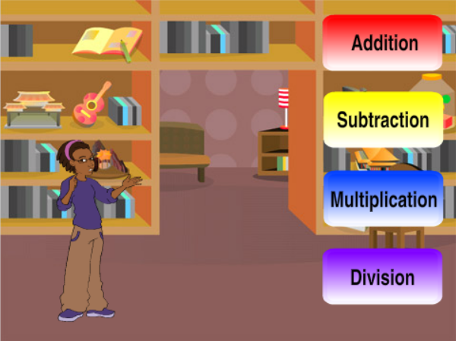

Figure 0:

* I have used Scratch to make a game that helps the student to do the math quizzes while having fun. I have used attractive visuals that kids can relate to. This will make it more enjoyable for kids aged between 3 and 7. Not only that, I have kept the settings as simple as possible so that the kids can understand how it works within seconds.

1. **Background/Literature Review**

* There are many websites that I have gone through which helped me get an overall idea of how maths game works and how to make it more interesting for the children. I came across a very interesting maths game on bbc.co.uk known as Defenders of Mathematica. This game helps the children learn and enhance their maths skills. Moreover, this game will give children the opportunities for building self-concept and developing positive attitudes toward mathematics, by reducing the fear of failure and error. After going through various websites, we decided to use scratch for the programming part of the project as scratch makes coding fun and easy to understand. Not only that, we will be using Figma for the concept design as it makes team collaboration simple and familiar.

**Figure 1**

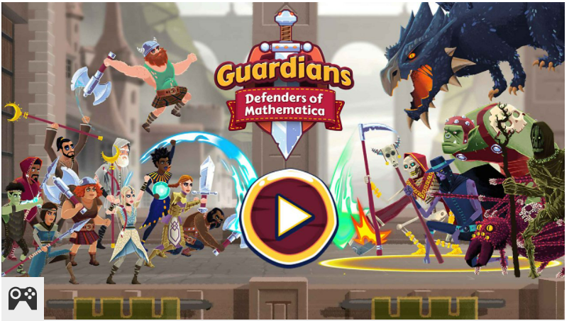

* I have some screenshots from the website [www.teachwire.net](http://www.teachwire.net/) which helped me get some creative ideas that I used in our project. The picture is shown on figure 1

**Figure 2**

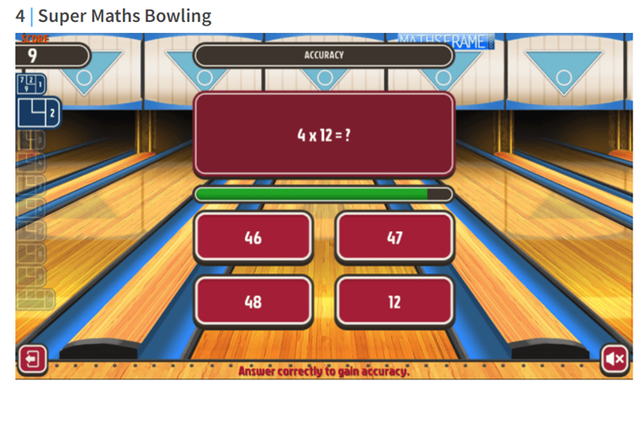

Figure 2:

* In this game, children need to answer the multiple-choice multiplication questions quickly and accurately, and the better they do the easier it is for them to aim the bowling ball at the pins by finding the right angle. You can choose difficulty by year group too.

**Figure 3**

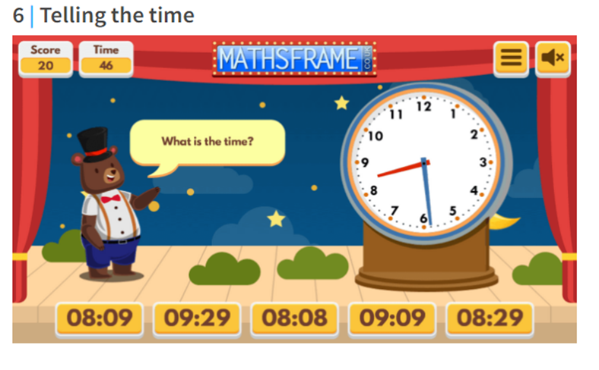

Figure 3:

* In this game, children can practice reading the time on an analog clock. There's plenty of choice over levels, so you can read time to the nearest hour, half-hour, quarter-hour, five minutes, or minute. Plus, you can use a 12- or 24-hour clock and play a timed or untimed game.

**Figure 4**

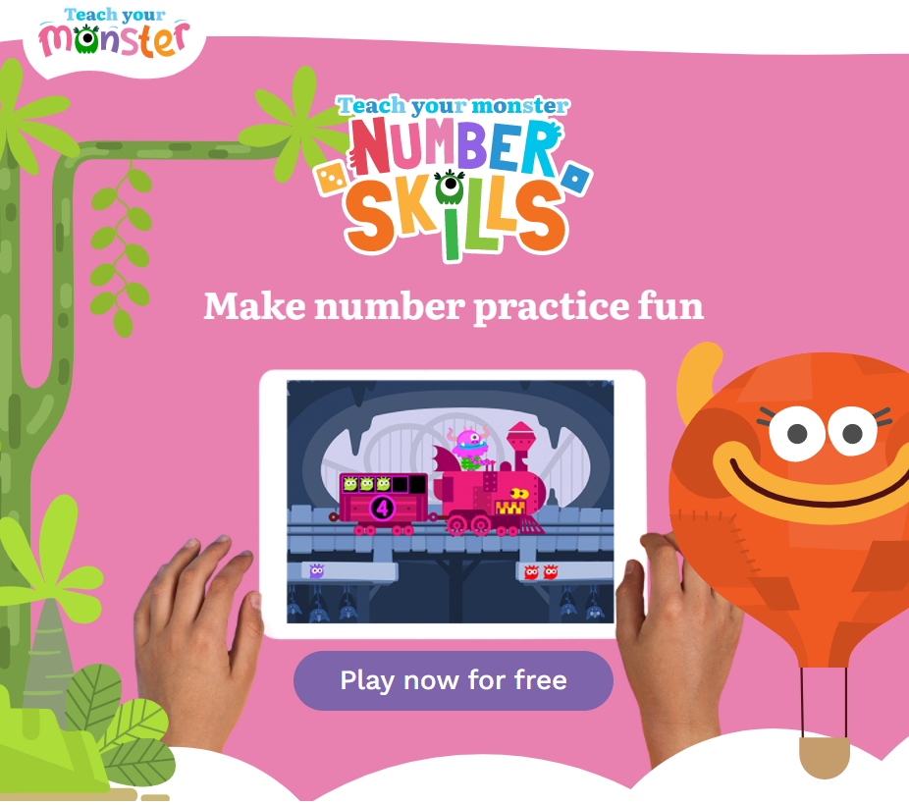

Figure 4:

* This information was taken from <https://www.teachyourmonster.org/>. Designed in collaboration with experts in early years mathematics. Fun-filled games offer exciting new ways to practice numbers. Aligned with Pre-K/Reception curriculum and enjoyable for ages 4-6+. There are 40 levels that provide structured practice in addition, subtraction, counting, number bonds, and more.

1. **Chosen methodology for your research, development, tools, and platforms.**

**Figure 5**

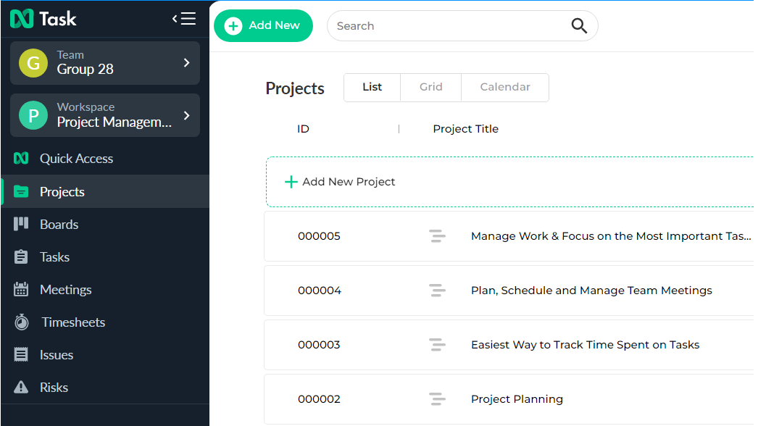

Figure 5:

* I have used Task to manage my project because it makes teamwork a lot easier. We can easily monitor our project. The management module can help you streamline your project planning, resource management, task dependencies, financial summary, and manage your project deliverables.

1. **Manage Work & Focus on the Most Important Tasks**

* Task helps me stay organized and meet deadlines with task management in List View, Grid View, and Calendar view.

**THE KEY FEATURES:**

* Task Status and Priorities
* Set Planned & Actual Due Dates
* Add Multiple Assignees
* Attach Documents & Task Comments

1. **Ensure your Team is on the Same Page**

* It helps me work cooperatively with my team to maintain accountability and clarity in my projects. It also helps me ameliorate team communication and work visibility for successful task accomplishment.

**COLLABORATION FEATURES:**

* Team Chat
* Task Comments
* Bulk Team Invite
* Dedicated Workspaces

1. **Plan, Schedule, and Manage Team Meetings**

* The Task schedules meetings with all my team members and then let minutes of the meeting to be assessed and analyzed before publishing. No more obscurity on decisions and actions.

**MEETING FEATURES:**

* Syn Meetings with Calendar
* Follow-up Actions and Decision
* Meeting Agenda and Discussion Notes
* Recurring Meetings

**Figure 6**

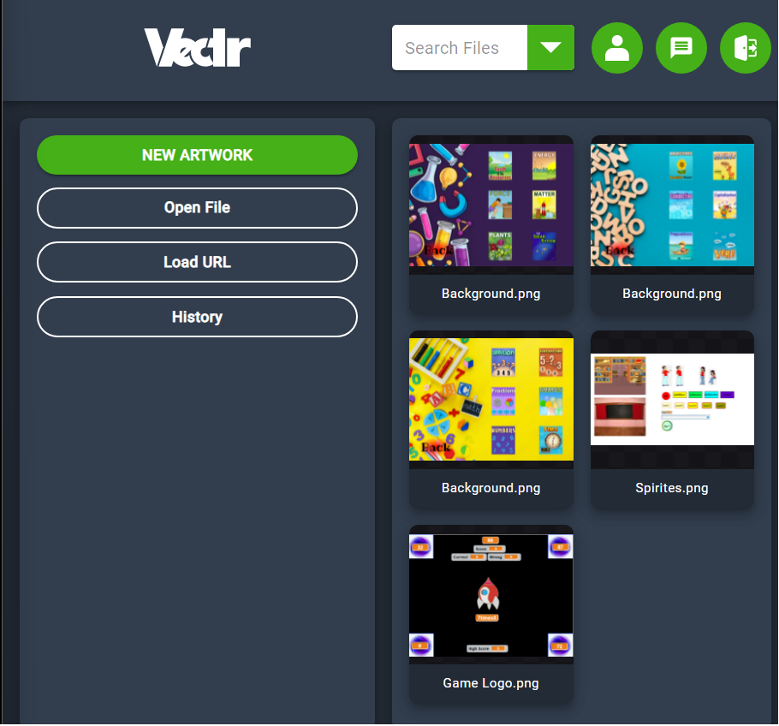

Figure 6:

* Vectr is a web-based graphics editor platform that is used to create vector graphics effortlessly and intuitively to bring designs into reality.
* Vectr is free, simple and the most inherent vector graphics editing software. Free vector graphics software is used to create graphics easily and instinctively. Vectr’s intuitive tools let me focus on what truly matters like creating beautiful graphic designs.
* Vectr helped me design my spirits and backgrounds. In Figure 6, I have shown you the designs that I have to draw to build up my quiz game website.

**Powerful vector graphics editor:**

* Precise and rock-solid vector graphics tools that work intuitively
* No learning curves
* SVG, PNG, JPEG files import
* Scale designs to any size without losing clarity

* I could have added more attractive visuals and more questions if I had gotten some help from my teammates. I wanted to add a helping section for the student who got most of the answers wrong. Not only that, but I also could have added different difficulties levels for weak and smart students so they could have worked at their own pace. I had to do almost everything by myself but it was a good learning experience. This project helped me learn how to build a website, design my own backgrounds and spirits, and made me more familiar with programming.

1. **Implementation of the system, including concept designs and any practical development and the final artefact or prototype.**

**Figure 7**

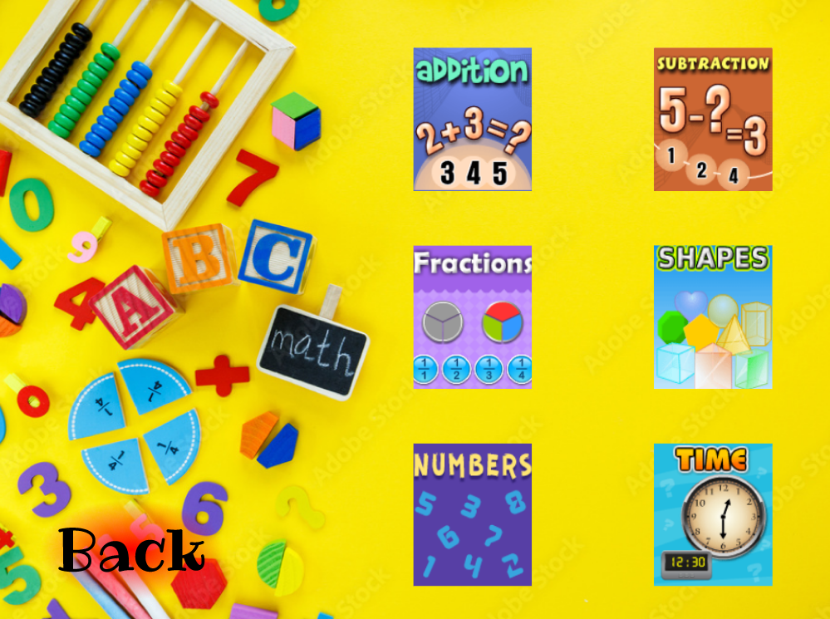

Figure 7:

* Math quiz helps us to expand our knowledge.
* Online math quizzes will take 5 minutes of your time to finish a set of questions on a math test quiz which will aid you to know how much you know about math quizzes and how much time you took to complete a set of math questions.

**Figure 8**

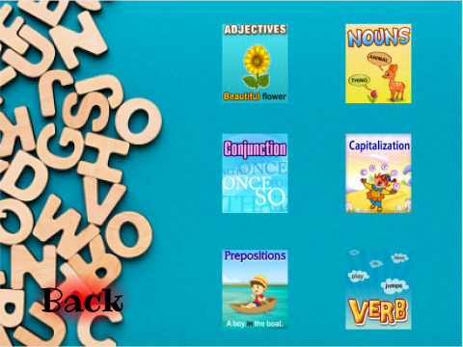

Figure 8:

* English quiz helps us to increase our knowledge of vocabulary. English quizzes can help the students practice existing knowledge while stimulating interest in learning about the new subject matter. There is a range of English topics and grammar which will help improve their English skills. These quizzes will help the children analyze in what area they have demonstrated learning gaps.

**Figure 9**

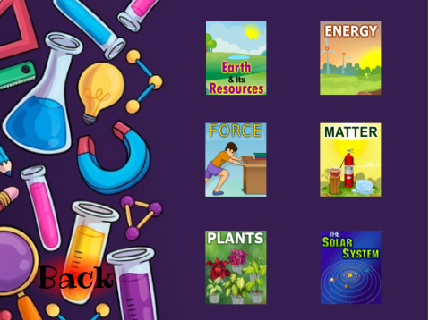

Figure 9:

* Science quizzes are essential for students who are appearing in any competitive exam. The main aim of science quiz questions is to check how well a student can comprehend the notion associated with science. These quiz questions help the students gain a basic understanding of [science](https://en.wikipedia.org/wiki/Science) so that they can effortlessly strive for any other related question in future exams. Science quizzes can drive you to learn. If you don’t do well enough on a science quiz, you may want to study harder for your next one. Science quizzes require students to know and apprehend their lessons and that means that they can also help students recall their lessons.

**Figure 10**

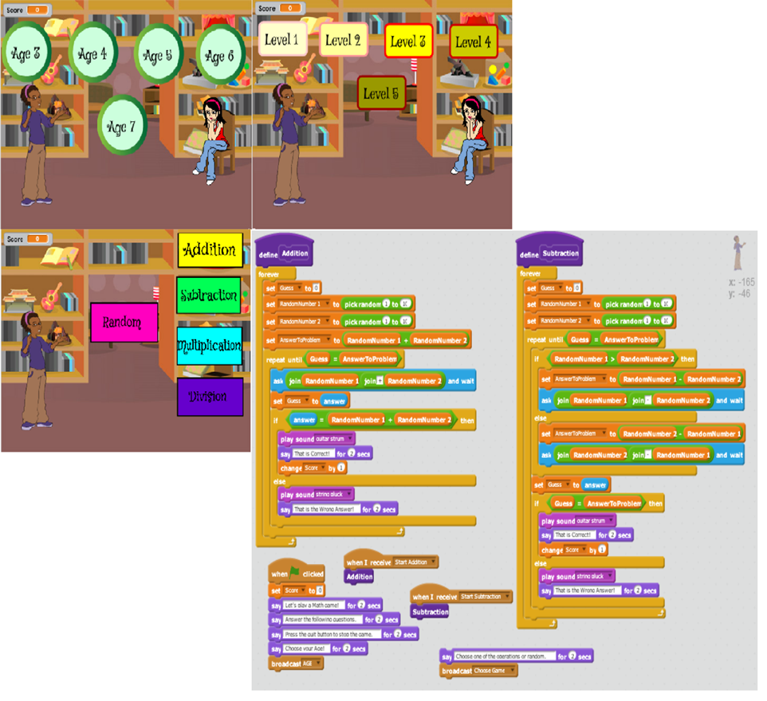

Figure 10:

* This game will let the children select their age and their difficulties levels. This way, students can make meaningful gains in learning, without always having to be in groups leveled by ability. In the picture above, I have also shown some of the programmings that I have done to make this game.

**Figure 11**

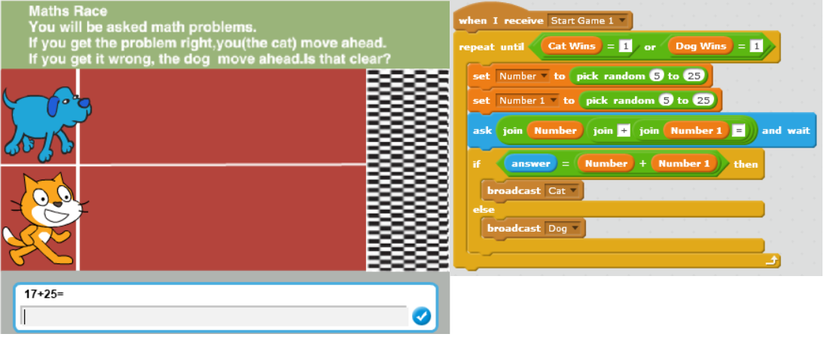

Figure 11:

* This feature will make it more fun for the children to play. They will be asked mathematical questions and if they got it correct the cat will move ahead towards the finishing line or else the dog will move ahead. If the cat reaches the finishing line first then the player wins.

**Figure 12**

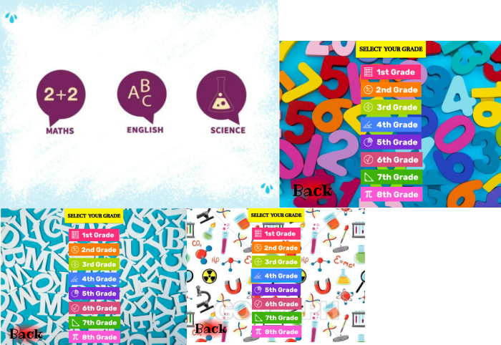

Figure 12:

* I have used Figma to make a concept design to make the game visuals more attractive to the children. This application makes it easy to design and add attractive visuals to the game. This way, players will have more fun while playing the game and will not get bored easily. According to some research, it has proven that attractive visuals help children memorize things without a hitch.

**Figure 13**

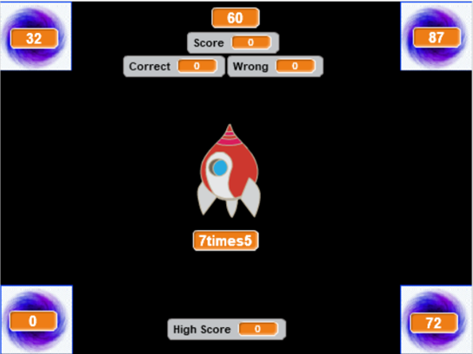

Figure 13:

* In this part of the game, the player will be asked some arithmetic questions and they have to fly the ship towards the correct portal using the arrow keys on the keyboard. They will have a limited amount of time and each time the player got the answer correct a clapping sound will be played and Correct Board will be updated. The sound and visuals of the game will make it more entertaining for the children to play. Not only that, this will help them realize how much time they took to solve a maths problem making them understand the importance of time management.

1. **Evaluation**

**Figure 14**

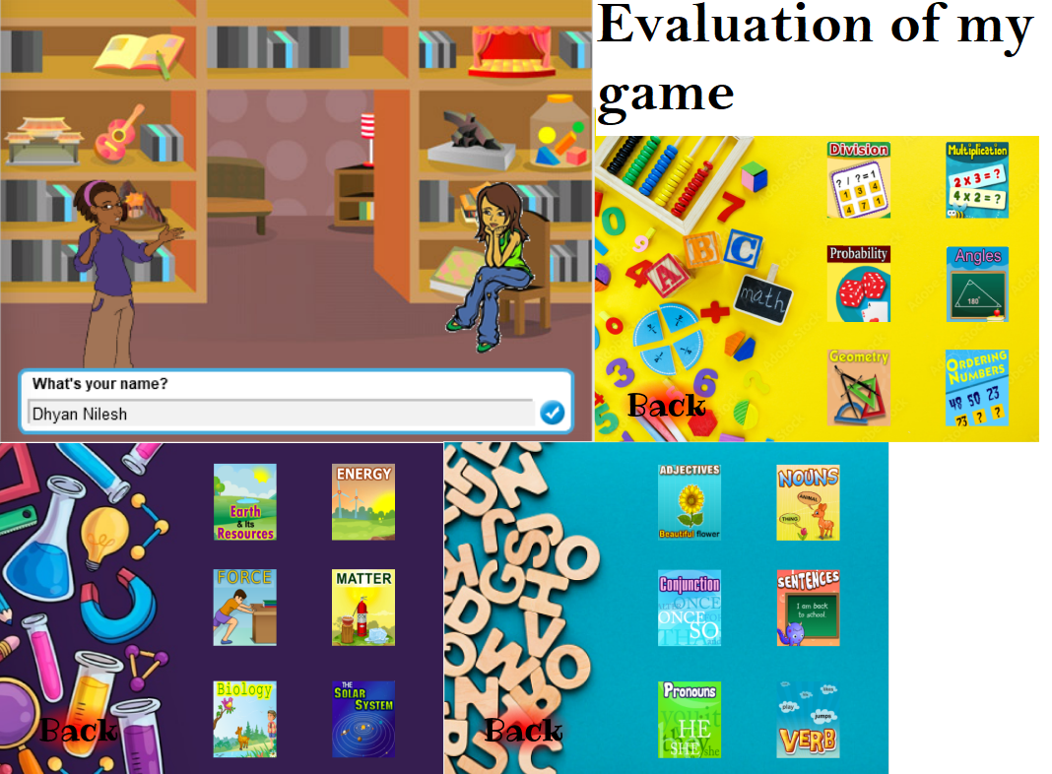

Figure 14:

* There are many things that I have added to my project to make my game more enjoyable and fun to play. First and foremost, I have included more Maths, English, Science problems, and attractive visuals in my game. Not only that, I need to assemble all the games that I have made for specific skills in one file. Moreover, the prototype that I have made has helped me find discrepancies and other issues early on in the design process. I have already resolved these issues so it does not negatively impact the user experience. I have also made a lot of improvements in my necessary facets like the setting, the level design, the characters, and the sound effects are working well. Furthermore, I have added various features to the game such as quizzes to test the student's knowledge of a unit before moving on.

**Figure 15**

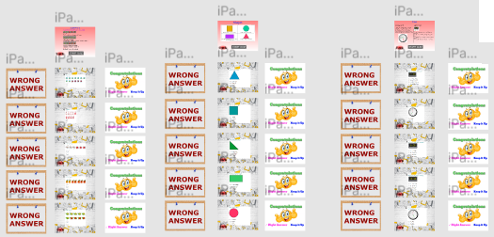

Figure 15:

* I have made the quiz game so that it will be helpful for students to identify what they know and what they don’t know. The students then have a better idea of how well they are grasping the material, hopefully inspiring them to study more. It will also help them assign their study time productively by concentrating on the information that still needs more practice.
* In Figure 15, I have shown pictures of some math questions that I have included. If you got the quiz wrong it will show “Wrong Answer” and if you got it right it will show “Congratulation Keep it up Right Answer” and will move you on to the next question. This is how the quiz game will work. I have kept it simple so kids around age 3 to 7 can easily grasp the concept.

1. **Conclusions**

* This Project has helped me gain a lot of programming and designing experience. I have learned how to use Figma to build a website of my own without doing a lot of programming. I have used Vectr to make my designs and backgrounds which help me gain a lot of exposure to designing. Moreover, this Vectr software has helped me put my ideas into reality. Not only that, I have learned a lot about Scratch and how to use it as means to create wonderful games. Furthermore, I got to know about nTask which help me manage my project.
* Unfortunately, my teammates were not that supportive but I enjoyed working on the project alone. I tried to contact them each and every week. Putting all that aside, I gain a lot of knowledge while doing this project. This project has helped me realize that we don’t need to always rely on others to do our work. This module has given me a lot of knowledge, experience, and skills and for that, I am very glad.

**END**

**Figma Project (My Quiz Game)**

* [**https://www.figma.com/file/EeDHJgda9Co4GYBdOqi79B/My-Quiz-Game**](https://www.figma.com/file/EeDHJgda9Co4GYBdOqi79B/My-Quiz-Game)

**Scratch (Download Scratch)**

* [**https://scratch.mit.edu/download**](https://scratch.mit.edu/download)